Just For Beginners - Jazz Improvisation for Beginners:
Part One
Play the scale slowly, at your own pace. Remember to take a deep breath, relax, and play with a good
sound. Once you feel comfortable with this scale we can move on to the next step - playing with a rhythm
section!
Before you start improvising, you need to learn the Bb major scale. If you already know your Bb major
scale by heart, you can skip to the next lesson, if you like. If you don't know your Bb scale, this is a good
time to learn! The scale is just below.
Instead of worrying about all those choices, let's make some of those choices for you (temporarily) so you
only think about one choice. With a little practice, you will be able to think about more than one thing, and
will be on your way to becoming a jazz trombonist.
It's easier than you think. The trick is to start simple. Most people, when they first improvise, become
overwhelmed by all the choices. What note should you play? Should you play it loud or soft? How long
should you hold the note?
So you want to learn how to improvise jazz. "Where do I begin?" you might ask. You have worked hard to
learn to read music, now how do you make it up on the spot?

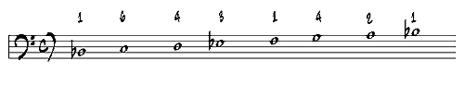

Start by playing through the Bb Scale Patterns sheet. It begins simply, but gets more difficult by the end, so if you can't play it all take some time to practice it before going on.

When you are ready, start playing the MIDI file. You will hear a series of clicks counting you into the beginning. If you want, just let it play for a while and listen to what the "rhythm section" is doing. Then try playing some of the scale patterns long with the MIDI file. If you get lost, don't worry, just start on any measure, as long as you are on a downbeat. As you play, listen carefully to how you sound. Are you playing with a good tone? Do the notes sound in tune to you? How does that Bb major scale sound against the rhythm section?

Eb Major
G Major
C Major
F Major
D Major

